Title: Install XAMPP and Configure DVWA
Objective: Install XAMPP on Windows to host the Damn Vulnerable Web App (DVWA) locally for penetration testing practice.
Requirements:
- Operating System: Windows 10 or 11.
- Storage: At least 500 MB of free space.
- Internet Connection: To download XAMPP and DVWA files.
Steps:
Step 1: Download and Install XAMPP
- Go to the official Apache Friends website: https://www.apachefriends.org/download.html
- Download the latest XAMPP for Windows installer.
- Run the .exe file, click "Next" through the default component selection, and install it to the default directory (C:\xampp).
Step 2: Start Apache and MySQL Services
- Open the "XAMPP Control Panel" from your Windows start menu.
- Click the "Start" button next to both Apache and MySQL.
- Wait for the modules to turn green, indicating the local web server and database are running.

Screenshot:
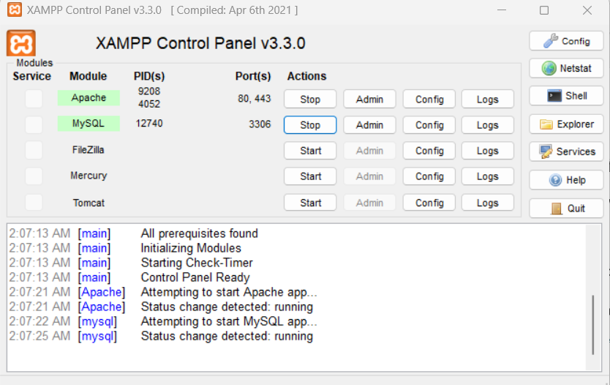
Step 3: Download DVWA
- Go to the official DVWA GitHub repository: https://github.com/digininja/DVWA
- Click the green "Code" button and select "Download ZIP".
Screenshot:
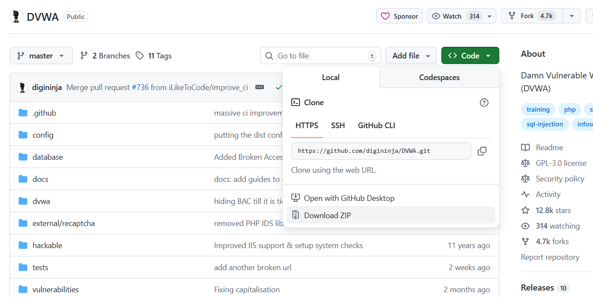

Step 4: Extract and Rename for Proof of Work
- Navigate to your Downloads folder and extract the DVWA ZIP file.
- Copy the extracted folder and paste it into the XAMPP web directory: C:\xampp\htdocs\
Screenshot:

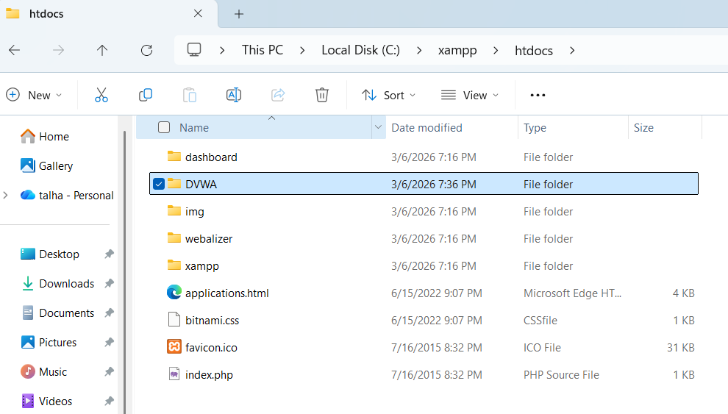
Step 5: Configure DVWA Database Settings
- Open your DVWA folder, then open the config folder inside it.
- Find the file named config.inc.php.dist and rename it to config.inc.php (remove the .dist).
- Open config.inc.php with Notepad. Find the line that says $_DVWA[ 'db_password' ] = 'password'; and remove the word password so it looks like this: $_DVWA[ 'db_password' ] = '';
- Save and close the file.
Screenshot: 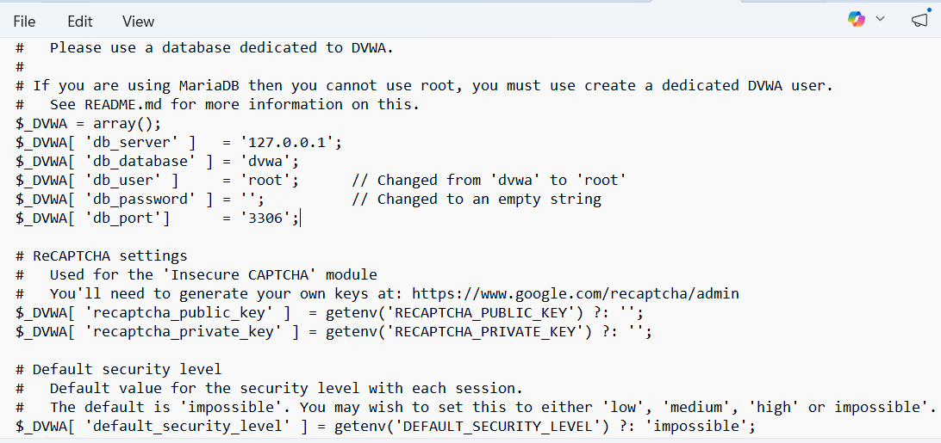
Step 6: Initialize the Database
- Open your web browser and go to: http://localhost/DVWA/setup.php
- Scroll to the bottom of the page and click the "Create / Reset Database" button.
- The page will refresh, and you should see a message saying the database was created successfully.
Step 7: Log in to DVWA
- You will be automatically redirected to the login page (or you can go to http://localhost/DVWA/login.php).
- Log in using the default credentials:
  - Username: admin
  - Password: password

Screenshot:

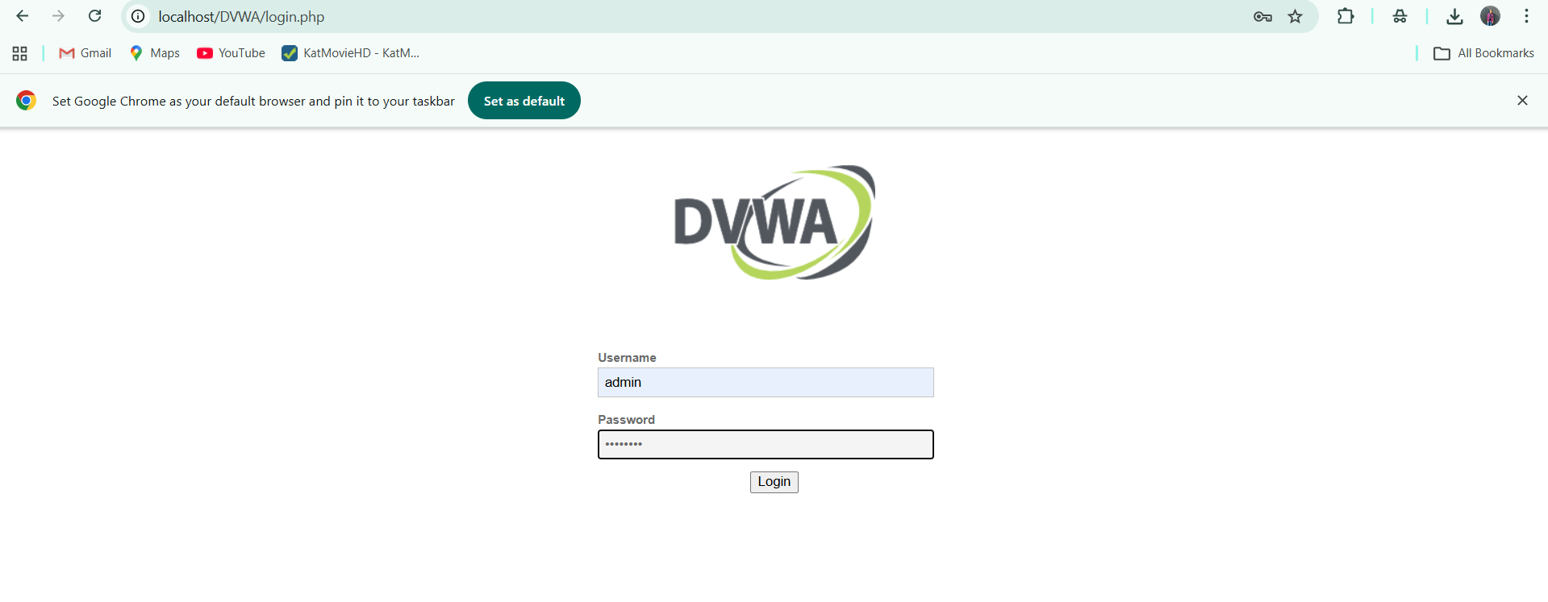
Result: XAMPP is fully operational on Windows, and DVWA is successfully configured and running out of your personalized Talha-DVWA directory, ready for vulnerability assessment tasks.
